Worksheet 1- A

If Mohamed ate 2/8 pizza and Jamel ate 4/8 pizza. What are the total pieces of pizza that Mohamed and Jamel ate? (Use the tools (pieces of pizza that made of cartoon) to help you to answer the question).

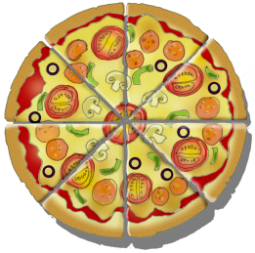

Worksheet 1- A

If Rami ate 6/8 pizza and Ibrahim ate 5/8 pizza. What are the total pieces of pizza that Rami and Ibrahim ate? (Use the tools (pieces of pizza that made of cartoon) to help you to answer the question).

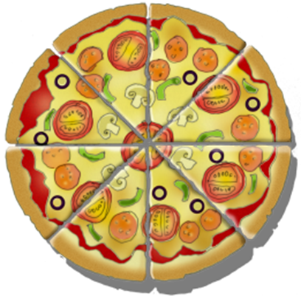

Work sheet 2-A

Represent the following fraction by shading squares (note: shade the squares that represent two fraction by using different color. Then find the total)

$\frac{4}{16}$ + $\frac{6}{16}=$

|  |  |  |  |
| --- | --- | --- | --- |
|  |  |  |  |
|  |  |  |  |
|  |  |  |  |
|  |  |  |  |

Work sheet 2-B

Represent the following fraction by shading squares (note: shade the squares that represent two fraction by using different color. Then find the total)

|  |  |  |
| --- | --- | --- |
|  |  |  |
|  |  |  |
|  |  |  |

|  |  |  |  |
| --- | --- | --- | --- |
|  |  |  |  |
|  |  |  |  |